Steps to Deploy Career Coach Agent

Step 1. Use the career coach template, copy and create new agent.
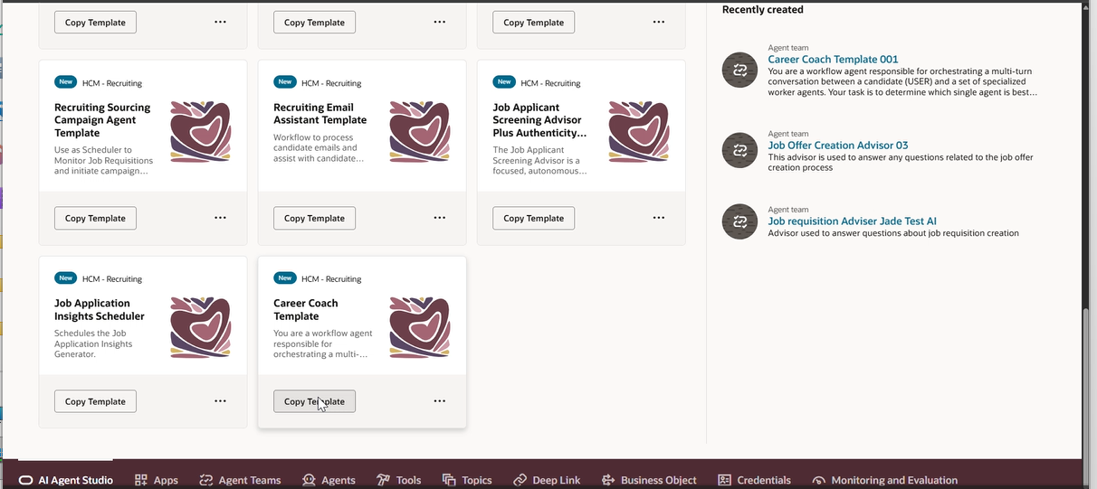

Step 2. Save and publish

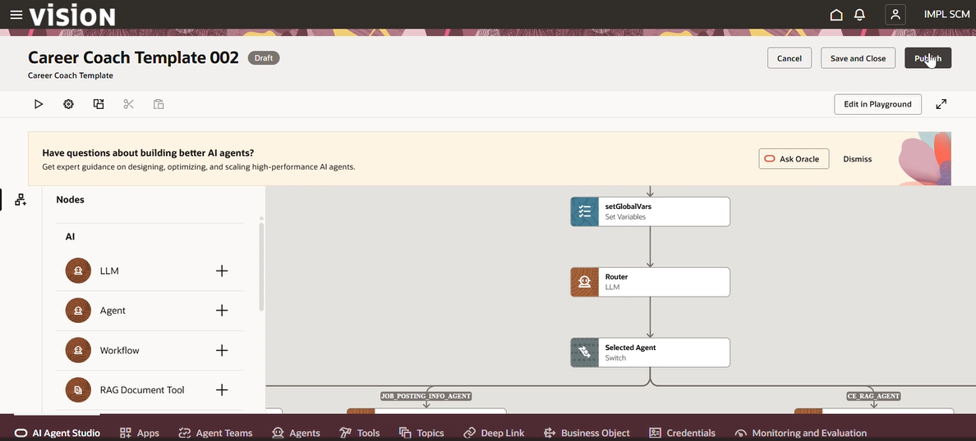

Step 3. Create new journey

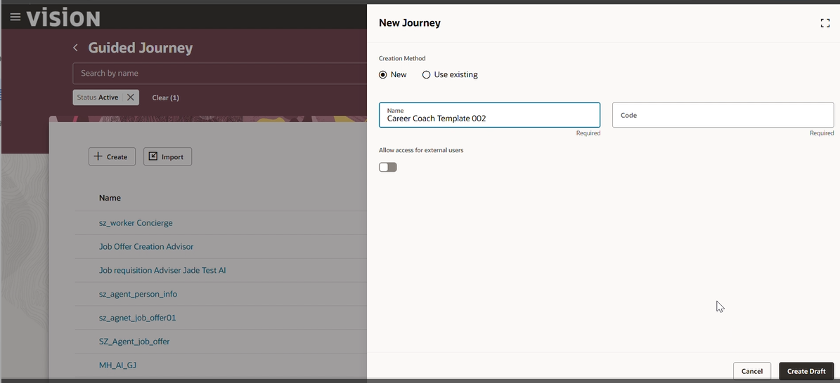

Step 4. Create new task for this journey, add the agent as workflow agent to that journey from the dropdown

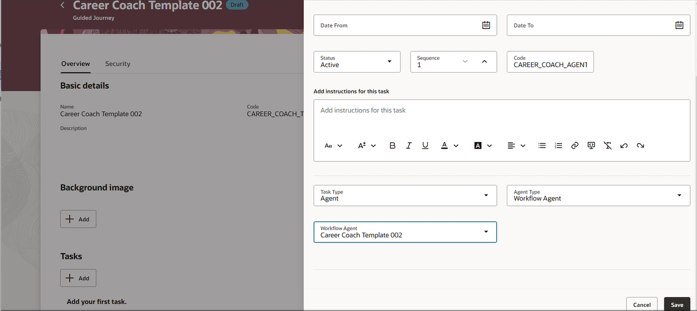

Step 5. Preview and test the guided journey

Step 6. Open the opportunity marketplace redwood page, edit with visual builder studio. Select the existing project or create new one., add the guided journey code in oppMktSearchJourneyCode field.

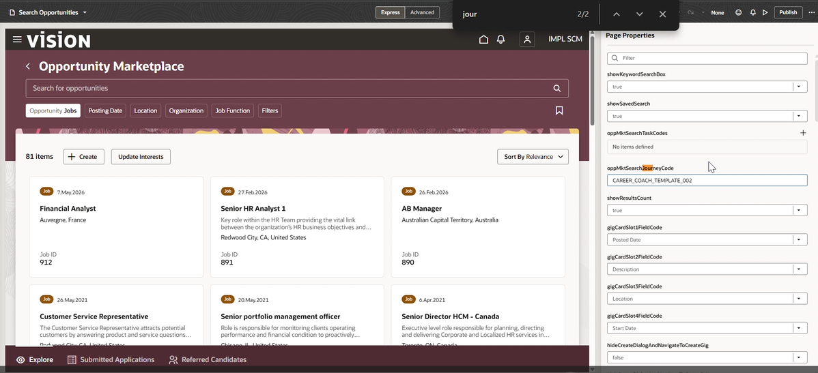

Step 7. Save and Publish on the instance.

Before:

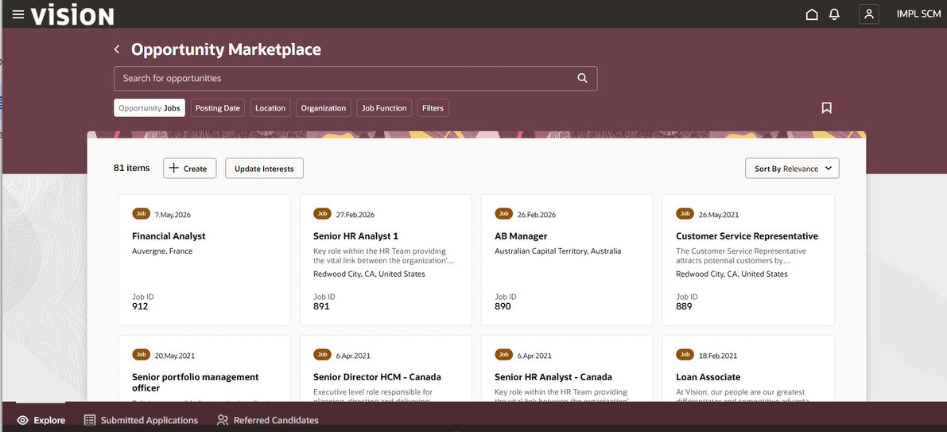

After:

